LAPORAN PENGERJAAN UJI KOMPETENSI KEJURUAN SMK MAHARDHIKA BATUJAJAR

TAHUN PELAJARAN 2022-2023

KOMPETENSI KEAHLIAN : Rekayasa Perangkat Lunak KELAS : XII RPL 1

NAMA LENGKAP : ZHAFIRA SYAHWA HAFIDZA

NIS :

PAKET SOAL : 2

JENIS APLIKASI : Web

ALOKASI WAKTU : 24 jam

# PENJADWALAN KEGIATAN

*Silahkan buat form penjadwalan dengan excel seperti yang pernah dicontohkan*

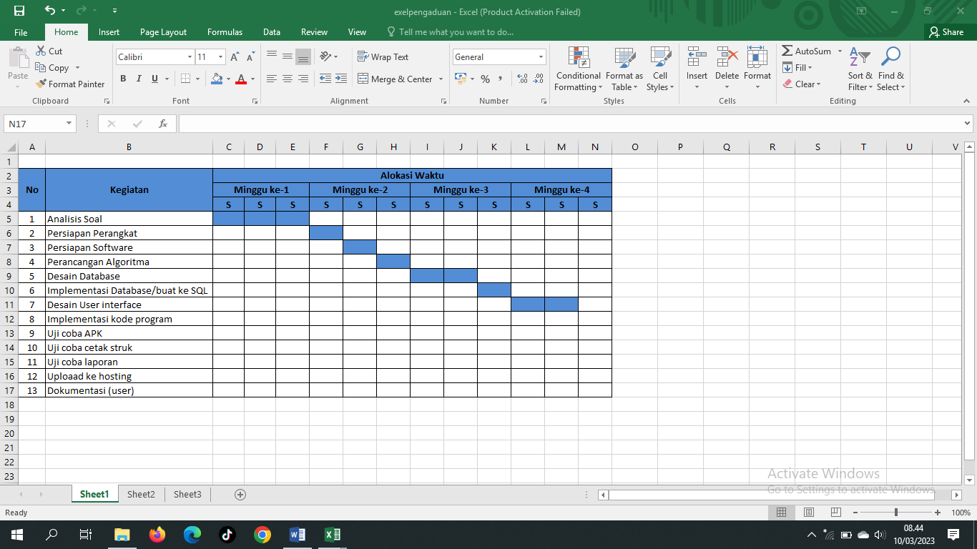

# PERSIAPAN PERANGKAT KERAS

*Silahkan isikan deskripsi/spesifikasi dari komputer/laptop yang kamu gunakan*

Defice specifications

1. Device name : DEKSTOP-CCK42BM
2. Processor : Intel(R) Core(TM) i3-6006U CPU @2.00GHz 2.00 GHz
3. Installed RAM : 4,00 GB (3,88 GB dapat digunakan)

# PERSIAPAN PERANGKAT LUNAK

*Silahkan isikan perangkat lunak yang terlibat dalam pembuatan project ini*

* Visual Studio Code
* MySQL
* Astah Pro
* Balsamiq
* Microsoft Word
* Microsoft Edge

# PERANCANGAN ALGORITMA APLIKASI

*Silahkan gambarkan activity diagram aplikasi yang kamu buat*

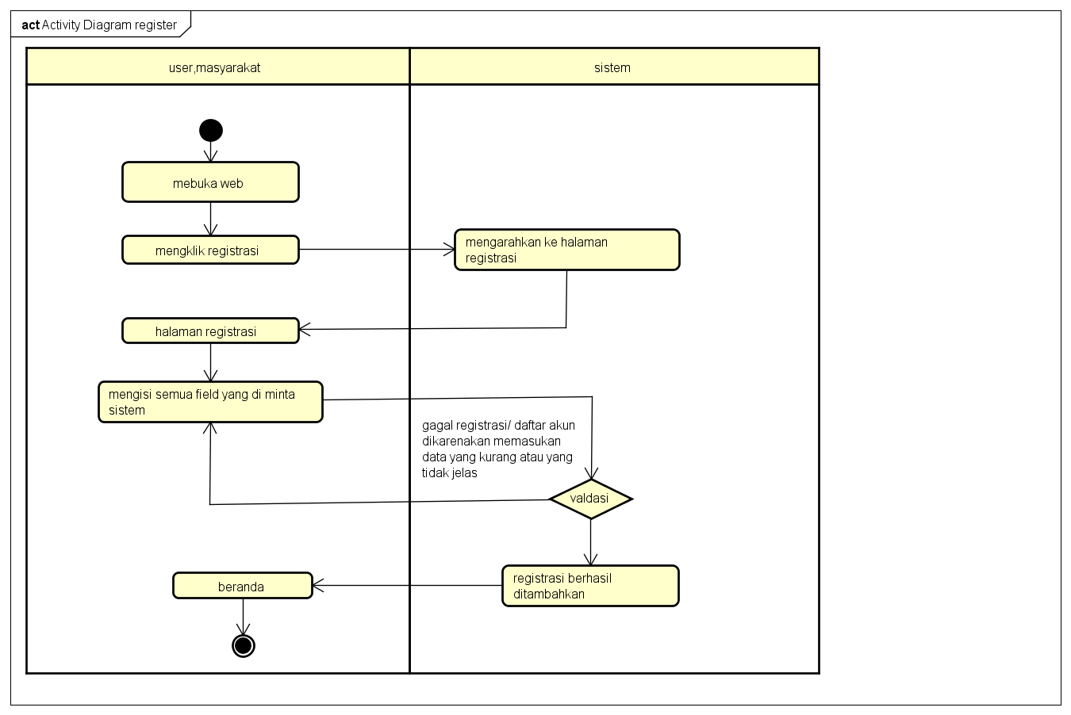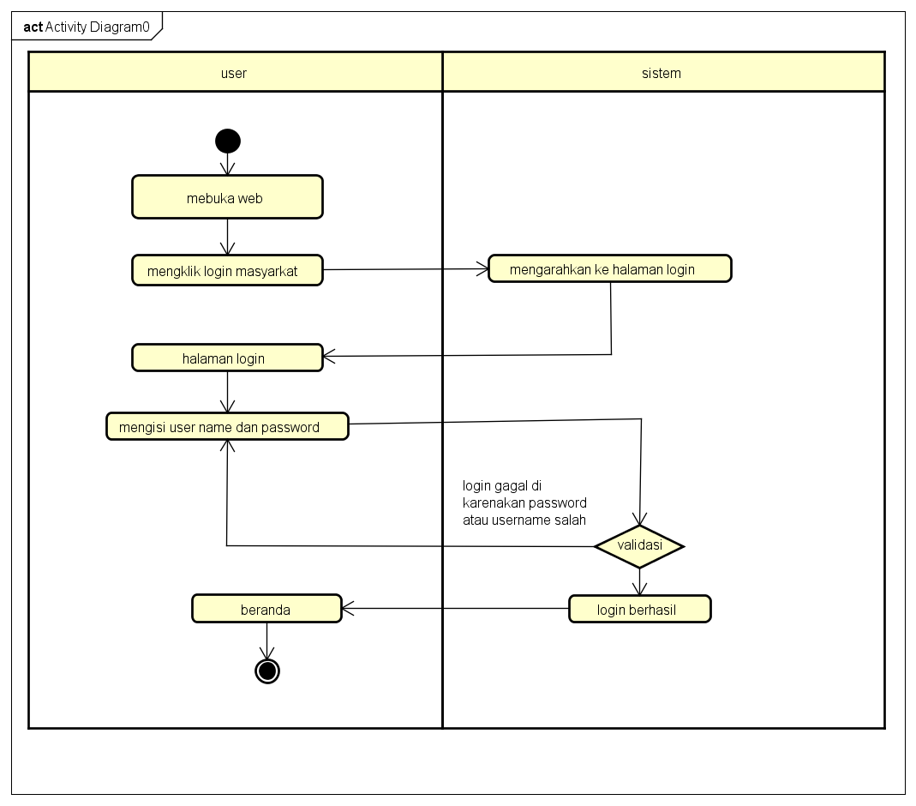

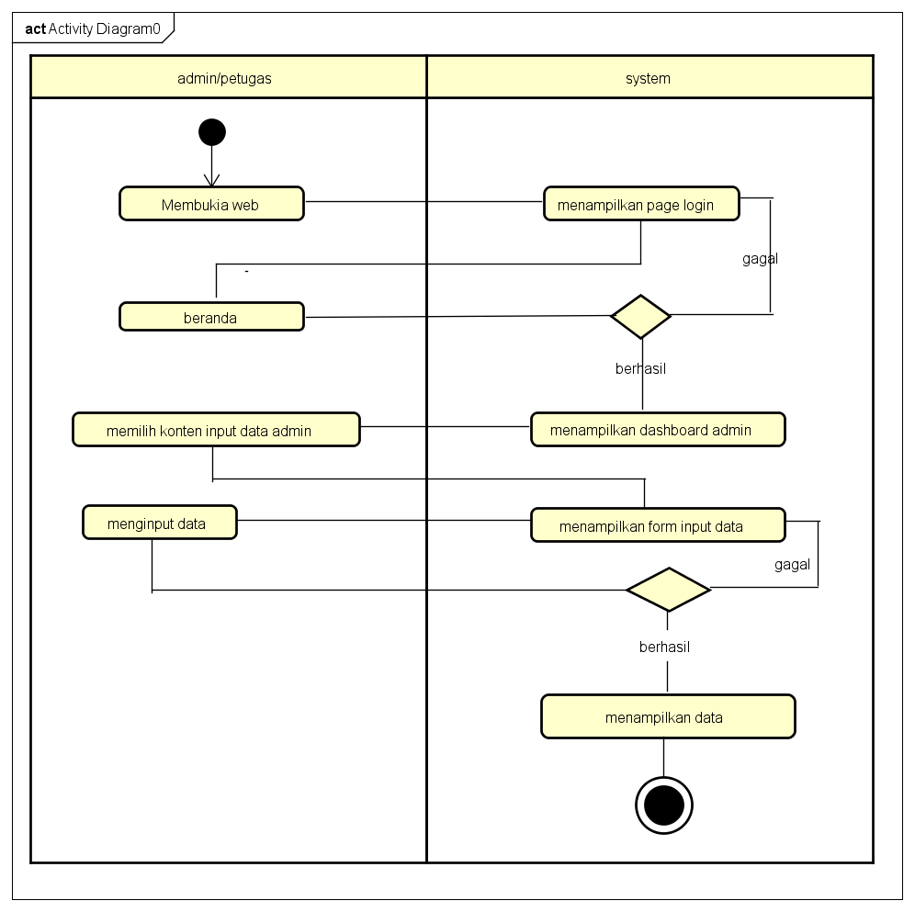

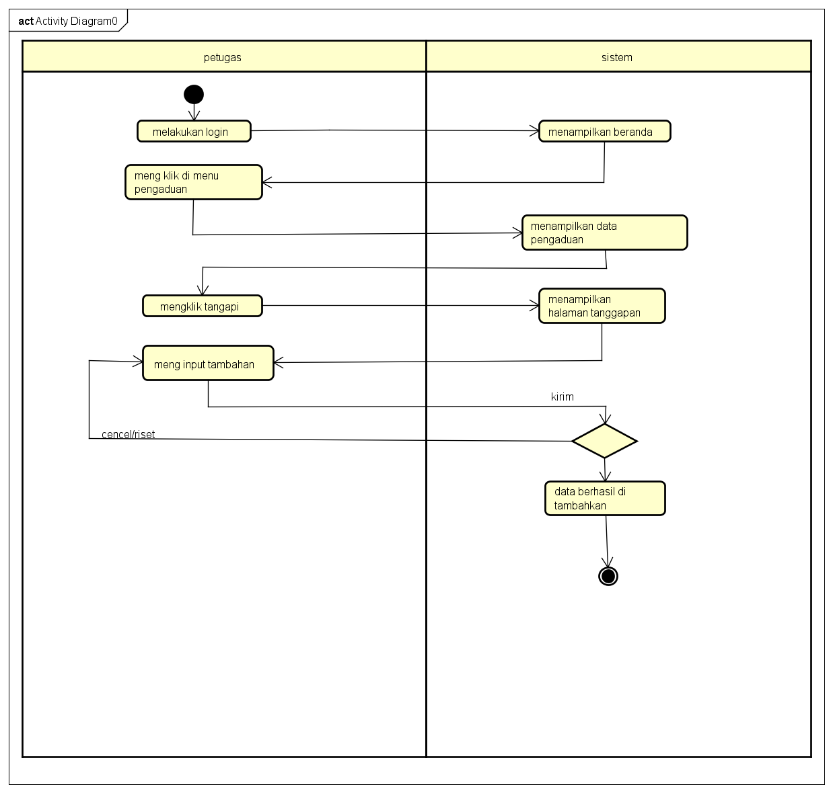

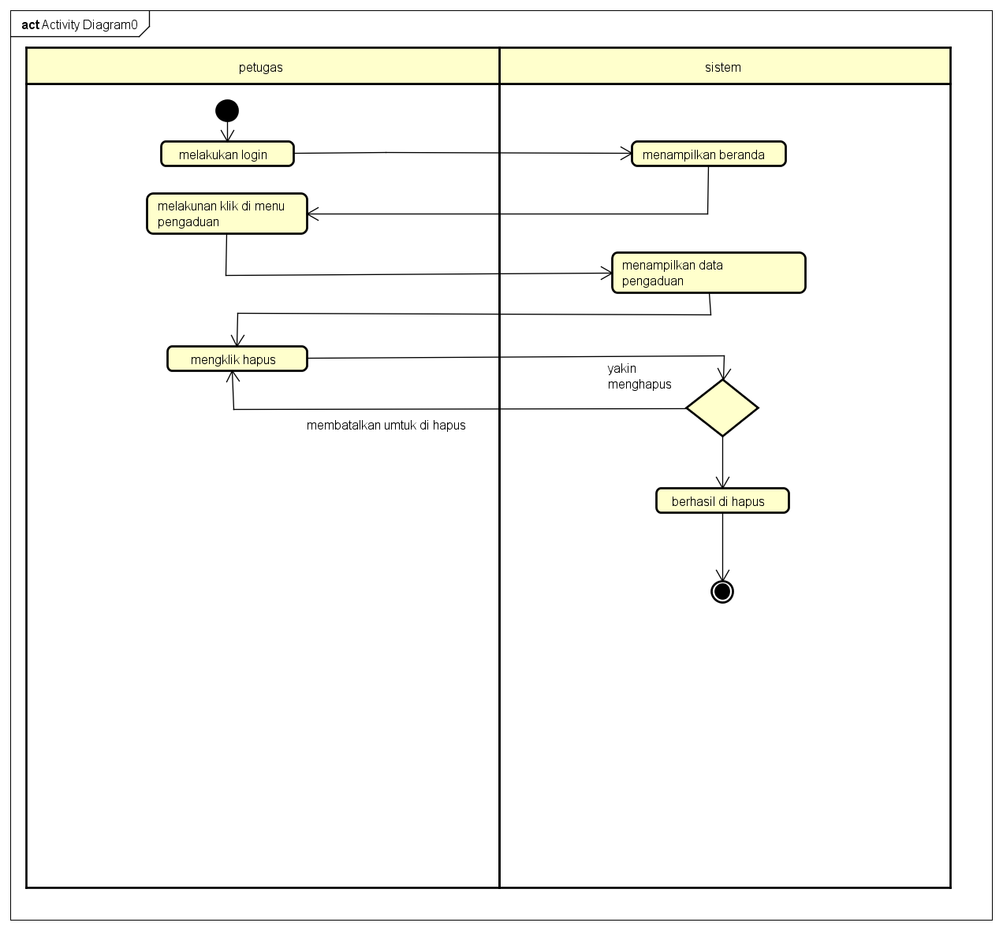

# PERANCANGAN DESAIN BASIS DATA

*Silahkan gambarkan ERD/DFD/class diagram atau desain basis data pada phpMyAdmin beserta relasinya*

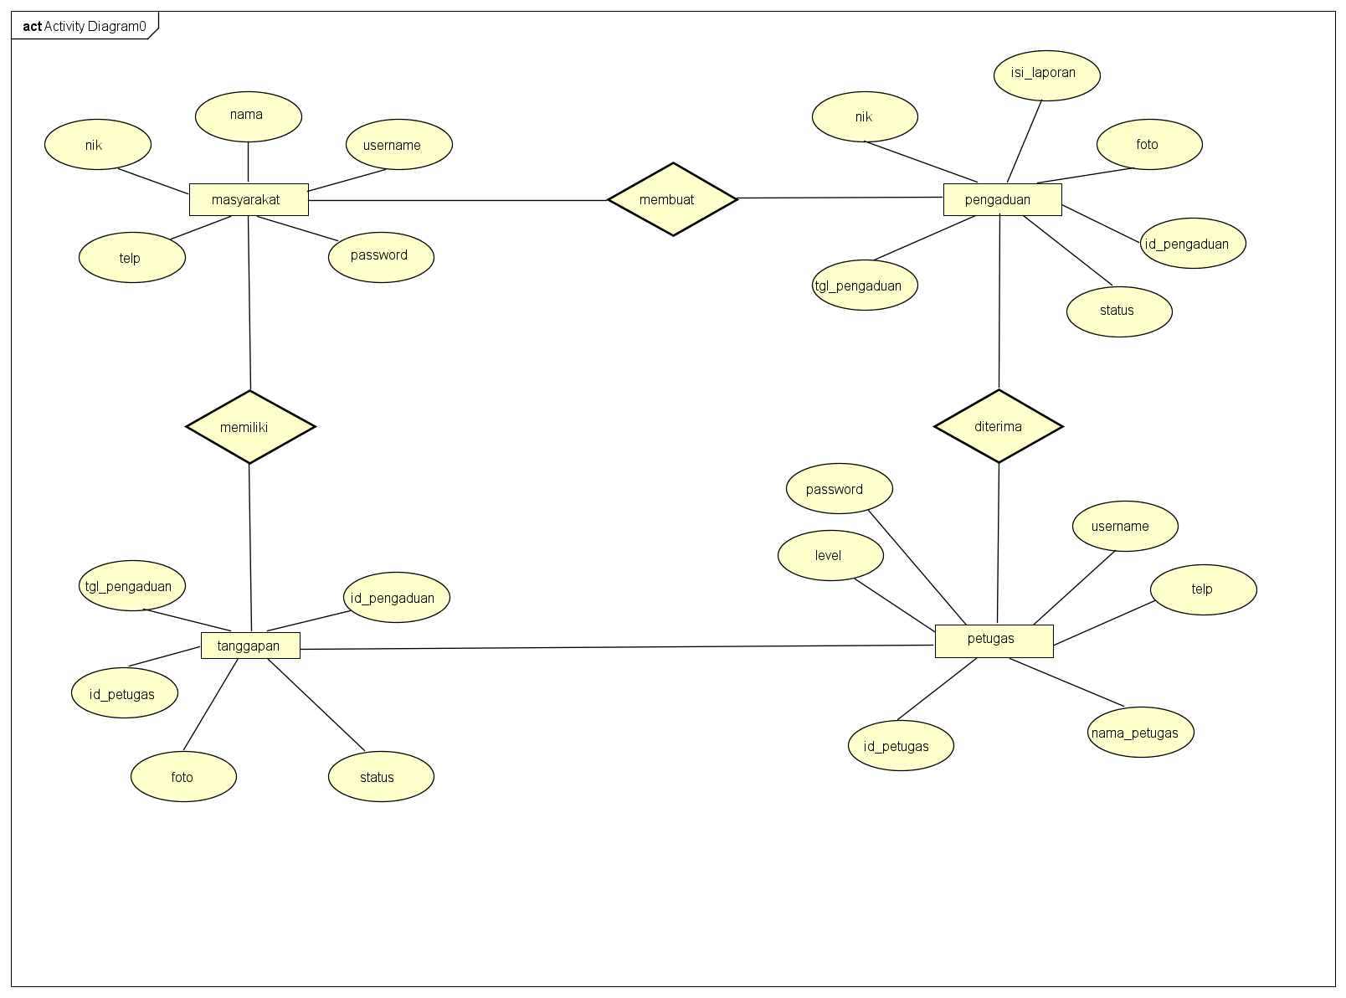

# DUMMY DATA

*Buat data dummy/bohongan yang dipersiapkan untuk nanti dimasukkan*

Data Masyarakat

|  |  |  |  |  |
| --- | --- | --- | --- | --- |
| nik | nama | username | password | telp |
| 3390098765365421 | Adit | adit | 123 | 089876767654 |
| 2090888767676565 | Santi | santi | 321 | 0999889878787 |
| 0000998889898787 | Irma | irma | 456 | 0897771123213 |
| 1112221245434256 | Rafki | rafki | 654 | 0998987878909 |
| 3333333555454654 | Rere | rere | 12345 | 0893321223432 |

Data Petugas

|  |  |  |  |  |  |
| --- | --- | --- | --- | --- | --- |
| Id_petugas | nama_petugas | username | password | telp_petugas | level |
| 33333 | Agung | agung | 0000 | 0898877787876 |  |
| 22222 | Caca | caca | 3333 | 08900000989889 |  |
| 11111 | Adi | adi | 8888 | 0892222111232 |  |
| 66666 | Reza | reza | 7777 | 0893333444545 |  |
| 99999 | Amel | amel | 55555 | 0897777666767 |  |

Data Admin

|  |  |  |  |  |  |
| --- | --- | --- | --- | --- | --- |
| Id_admin | nama_admin | username | password | telp_admin | level |
| 09876 | Andi | andi | 123 | 0898878787890 |  |
| 00000 | Julfa | julfa | 321 | 0892223212121 |  |
| 22111 | Safitri | fitri | 456 | 089770000000 |  |
| 45454 | Surya | surya | 654 | 089322121111 |  |
| 77676 | Lia | lia | 678 | 0894333333333 |  |

# PEMBUATAN BASIS DATA (MySQL Code)

*Silahkan buat basis data di PHPMyAdmin, jika sudah selesai bisa di copykan filenya di sini sebagai lampiran (*screenshot struktur tabel pada basis data yg dibuat)*

masyarakat

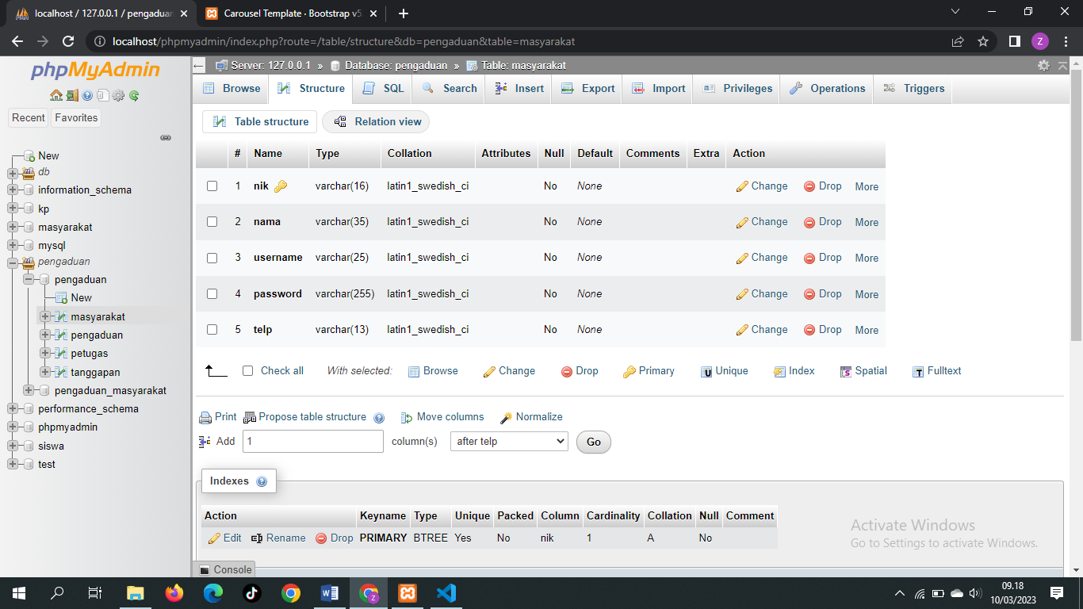

Pengaduan

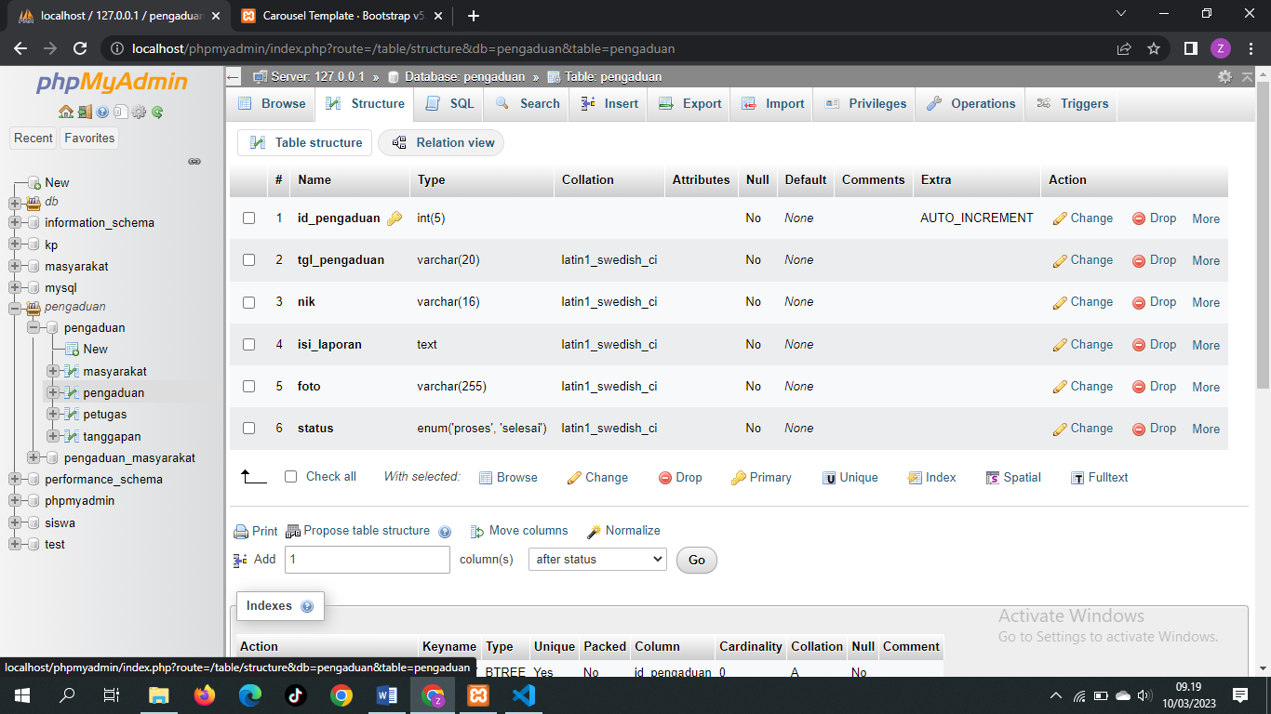

Petugas

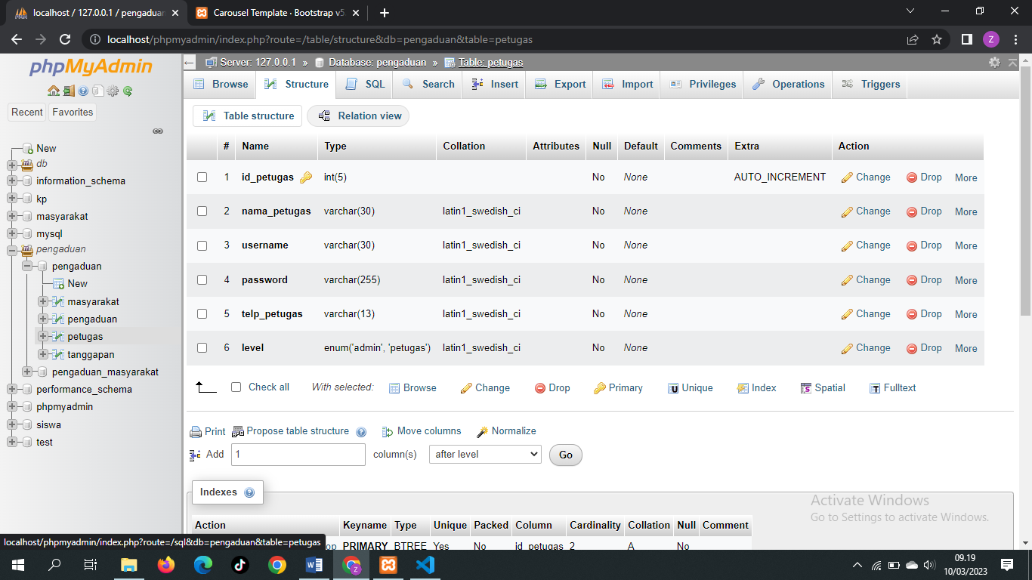

Tanggapan

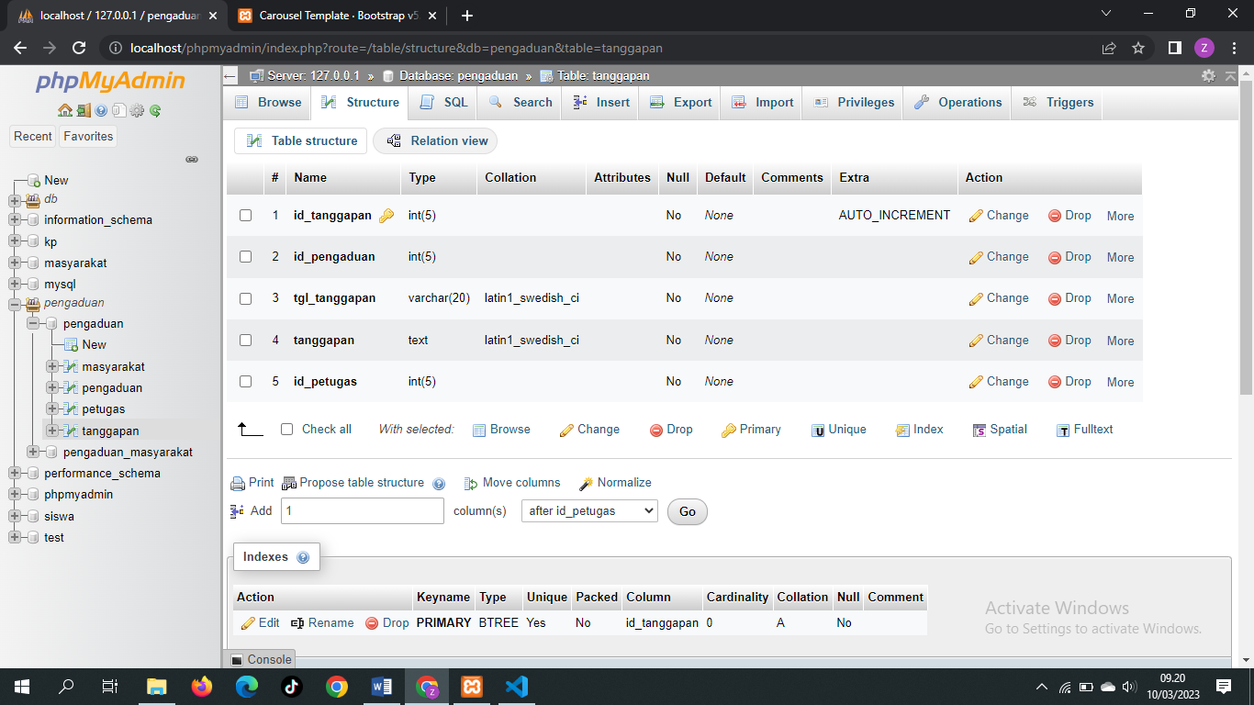

# PERANCANGAN TAMPILAN ANTARMUKA (UI) WEB

* + **Aplikasi pengaduan masyarakat**

1. *Silahkan gambarkan use case diagram aplikasi yang kamu buat*

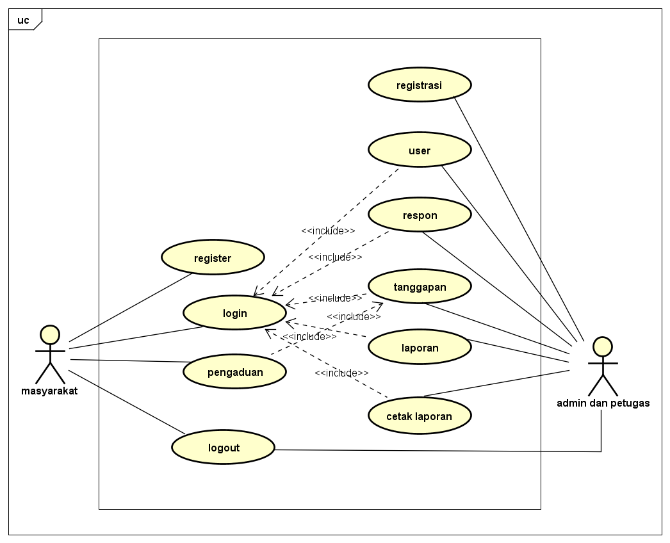

1. Admin dashboard

Tampilan untuk full manage semua data, buatkan sketsa/mockup-nya

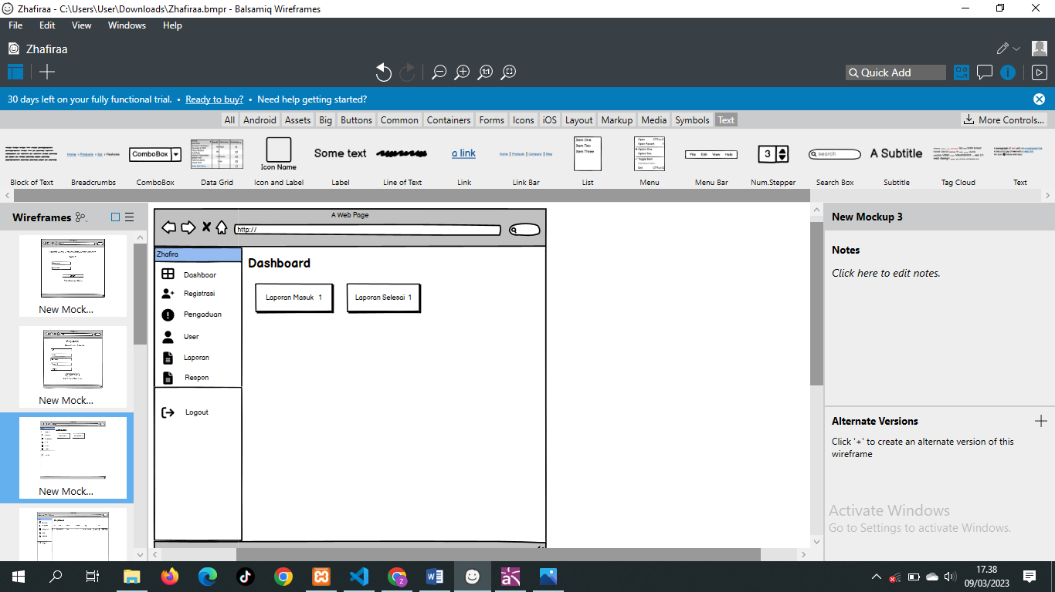

1. Tampilan Petugas buatkan sketsa/mockup-nya

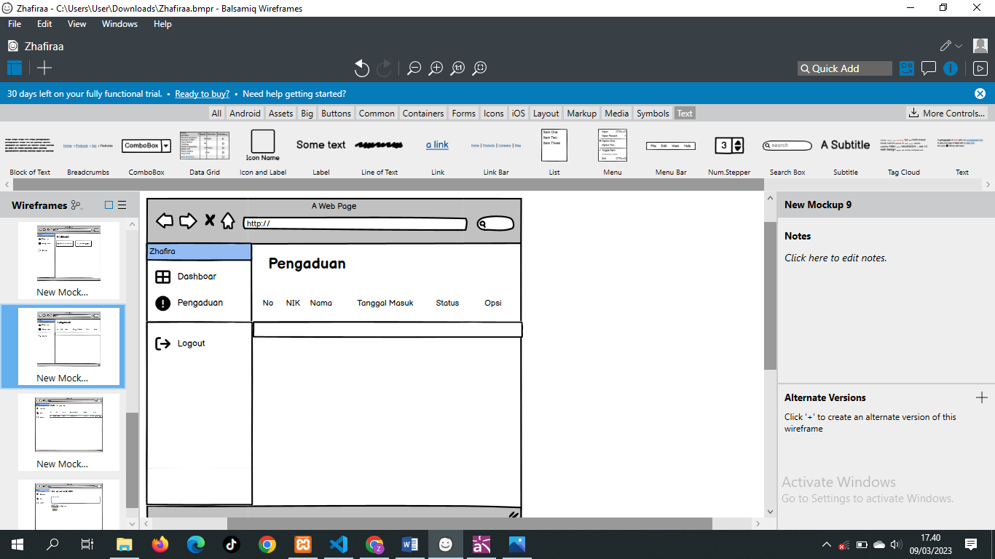

1. Tampilan masyarakat

Dashboard,about,tambah laporan,daftar komentar, tanggapan, buatkan sketsa/mockup-nya

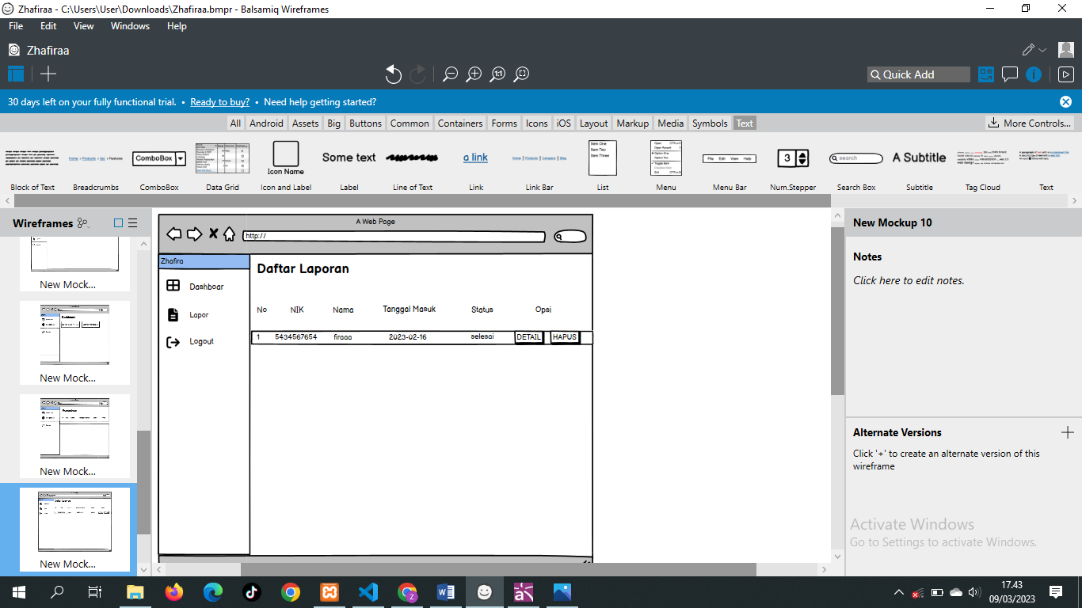

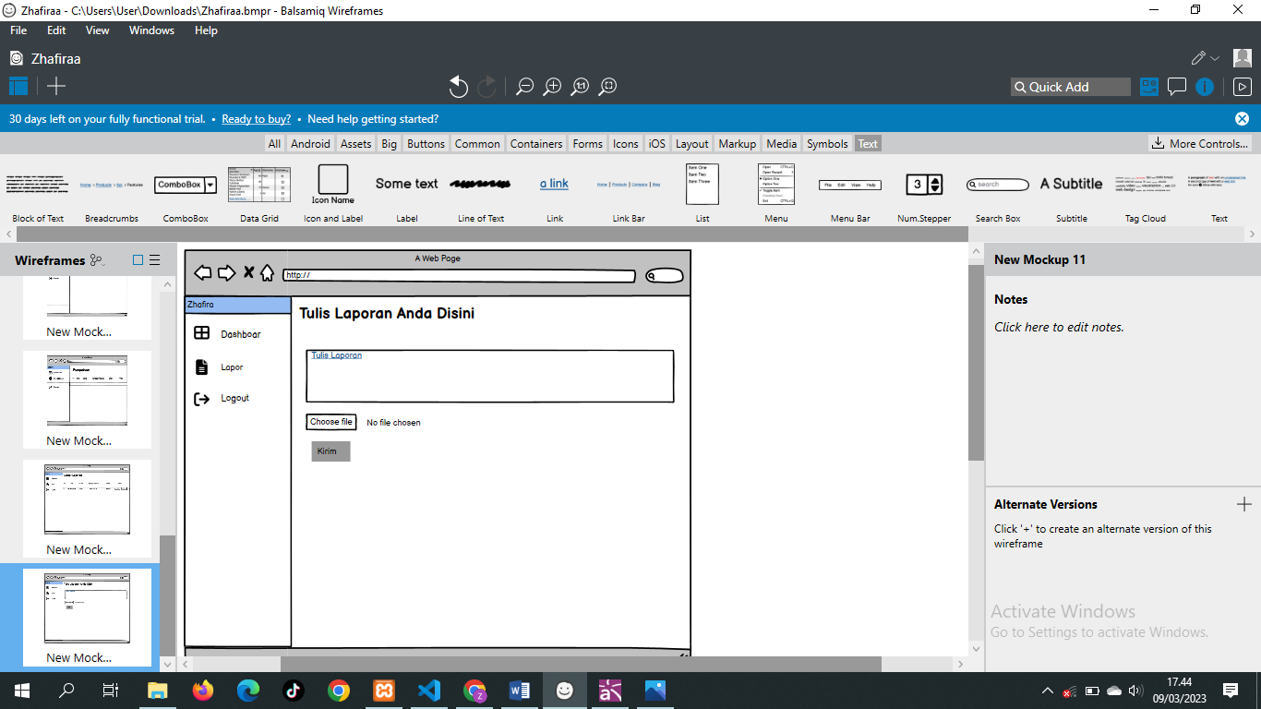

# Aplikasi pengelolaan laundry

1. *Silahkan gambarkan use case diagram aplikasi yang kamu buat*
2. Admin dashboard

Tampilan untuk full manage semua data, buatkan sketsa/mockup-nya

1. Tampilan Kasir

Setiap menu buatkan sketsa/mockup-nya

1. Tampilan owner

Setiap menu buatkan sketsa/mockup-nya

# PEMBUATAN STRUKTUR WEB (HTML)

1. **PEMBUATAN STYLE WEB (CSS)**

File style.css

|  |
| --- |
| /* GLOBAL STYLES  -------------------------------------------------- */  /* Padding below the footer and lighter body text */  body {    padding-top: 3rem;    padding-bottom: 3rem;    color: #5a5a5a;  }  /* CUSTOMIZE THE CAROUSEL  -------------------------------------------------- */  /* Carousel base class */  .carousel {    margin-bottom: 4rem;  }  /* Since positioning the image, we need to help out the caption */  .carousel-caption {    bottom: 3rem;    z-index: 10;  }  /* Declare heights because of positioning of img element */  .carousel-item {    height: 32rem;  }  /* MARKETING CONTENT  -------------------------------------------------- */  /* Center align the text within the three columns below the carousel */  .marketing .col-lg-4 {    margin-bottom: 1.5rem;    text-align: center;  }  /* rtl:begin:ignore */  .marketing .col-lg-4 p {    margin-right: .75rem;    margin-left: .75rem;  }  /* rtl:end:ignore */  /* Featurettes  ------------------------- */  .featurette-divider {    margin: 5rem 0; /* Space out the Bootstrap <hr> more */  }  /* Thin out the marketing headings */  /* rtl:begin:remove */  .featurette-heading {    letter-spacing: -.05rem;  }  /* rtl:end:remove */  /* RESPONSIVE CSS  -------------------------------------------------- */  @media (min-width: 40em) {    /* Bump up size of carousel content */    .carousel-caption p {      margin-bottom: 1.25rem;      font-size: 1.25rem;      line-height: 1.4;    }    .featurette-heading {      font-size: 50px;    }  }  @media (min-width: 62em) {    .featurette-heading {      margin-top: 7rem;    }  } |

1. **PEMBUATAN KODE WEB (PHP/JS)**

File index.php

|  |
| --- |
| <?php    session_start();    error_reporting(0);    include '../conn/koneksi.php';    if(!isset($_SESSION['username'])){      header('location:../index.php');    }    elseif($_SESSION['level'] != "masyarakat"){      header('location:../index.php');    }   ?>    <!DOCTYPE html>    <html>      <head>        <title>Aplikasi Pengaduan masyarakat</title>        <!--Import Google Icon Font-->        <link href="https://fonts.googleapis.com/icon?family=Material+Icons" rel="stylesheet">        <!--Import materialize.css-->        <link type="text/css" rel="stylesheet" href="../css/materialize.min.css"  media="screen,projection"/>        <!-- Compiled and minified CSS -->        <link rel="stylesheet" href="https://cdnjs.cloudflare.com/ajax/libs/materialize/1.0.0/css/materialize.min.css">        <!-- Compiled and minified JavaScript -->        <script src="https://cdnjs.cloudflare.com/ajax/libs/materialize/1.0.0/js/materialize.min.js"></script>        <script src="https://ajax.googleapis.com/ajax/libs/jquery/3.4.1/jquery.min.js"></script>        <!--Let browser know website is optimized for mobile-->        <meta name="viewport" content="width=device-width, initial-scale=1.0"/>        <link rel="stylesheet" type="text/css" href="https://cdn.datatables.net/1.10.19/css/jquery.dataTables.css">          <script src="https://ajax.googleapis.com/ajax/libs/jquery/3.4.1/jquery.min.js"></script>          <script type="text/javascript" charset="utf8" src="https://cdn.datatables.net/1.10.19/js/jquery.dataTables.js"></script>            <script type="text/javascript">          $(document).ready( function () {            $('#example').DataTable();            $('select').formSelect();          } );          </script>      </head>      <body style="background:url(../img/p.jpeg); background-size: cover;">      <div class="row">        <div class="col s12 m3">            <ul id="slide-out" class="sidenav sidenav-fixed">                <li>                    <div class="user-view">                        <div class="background">                            <img src="../img/bg1.png">                        </div>                        <a href="#name"><span class="black-text name"><b><?php echo ucwords($_SESSION['data']['nama']); ?></b></span></a>                    </div>                </li>                <li><a href="index.php?p=dashboard"><i class="material-icons black-text"></i><b>Dashboard</b></a></li>                <li><a href="index.php?p=laporan"><i class="material-icons black-text"></i><b>Lapor</b></a></li>                <li>                  </li>                <li><a class="waves-effect" href="../index.php?p=logout"><i class="material-icons black-text"></i><b>Logout</b></a></li>            </ul>          </div>        <div class="col s12 m9">      <?php      if(@$_GET['p']==""){        include_once 'dashboard.php';      }      elseif(@$_GET['p']=="dashboard"){        include_once 'dashboard.php';      }      elseif(@$_GET['p']=="laporan"){        include_once 'lapor.php';      }      elseif(@$_GET['p']=="pengaduan_hapus"){        $query=mysqli_query($koneksi,"SELECT * FROM pengaduan WHERE id_pengaduan='".$_GET['id_pengaduan']."'");        $data=mysqli_fetch_assoc($query);        unlink('../img/'.$data['foto']);        if($data['status']=="proses"){          $delete=mysqli_query($koneksi,"DELETE FROM pengaduan WHERE id_pengaduan='".$_GET['id_pengaduan']."'");          header('location:index.php?p=dashboard');        }        elseif($data['status']=="selesai"){          $delete=mysqli_query($koneksi,"DELETE FROM pengaduan WHERE id_pengaduan='".$_GET['id_pengaduan']."'");          if($delete){            $delete2=mysqli_query($koneksi,"DELETE FROM tanggapan WHERE id_pengaduan='".$_GET['id_pengaduan']."'");            header('location:index.php?p=dashboard');          }        }      }      elseif(@$_GET['p']=="more"){        include_once 'more.php';      }     ?>        </div>      </div>          <!--JavaScript at end of body for optimized loading-->        <script type="text/javascript" src="../js/materialize.min.js"></script>        <script type="text/javascript" src="https://cdnjs.cloudflare.com/ajax/libs/materialize/1.0.0/js/materialize.min.js"></script>        <script type="text/javascript">          document.addEventListener('DOMContentLoaded', function() {            var elems = document.querySelectorAll('.sidenav');            var instances = M.Sidenav.init(elems);          });          document.addEventListener('DOMContentLoaded', function() {            var elems = document.querySelectorAll('.modal');            var instances = M.Modal.init(elems);          });        </script>      </body>    </html> |

File koneksi.php

|  |
| --- |
| <?php $koneksi= mysqli_connect("localhost","root","","pengaduan"); ?> |

CRUD file

|  |
| --- |
| <?php include 'conn/koneksi.php'; ?>  <!DOCTYPE html>  <html>  <head>      <title>Aplikasi Pengaduan Masyarakat</title>      <link rel="shortcut icon" href="https://cepatpilih.com/image/logo.png">      <meta charset="utf-8">      <meta http-equiv="X-UA-Compatible" content="IE=edge,chrome=1">      <meta name="viewport" content="width=device-width, initial-scale=1.0, maximum-scale=1.0, user-scalable=0">      <link href="//cdnjs.cloudflare.com/ajax/libs/materialize/0.98.2/css/materialize.min.css" rel="stylesheet" id="bootstrap-css">      <script src="//cdnjs.cloudflare.com/ajax/libs/materialize/0.98.2/js/materialize.min.js"></script>      <script src="//code.jquery.com/jquery-1.11.1.min.js"></script>      <link rel="stylesheet" type="text/css" href="css/style.css">      <!-- ICONS -->      <link rel="apple-touch-icon" sizes="76x76" href="assets/img/apple-icon.png">      <link rel="icon" type="image/png" sizes="96x96" href="assets/img/favicon.png">  </head>  <body style="background: url(img/ab.jpeg); background-size: cover;">  </body>  </html>  <div class="card" style="padding: 25px; width: 40%; margin: 0 auto; margin-top: 0,5%;">  <b><h3 style="text-align: center;" class="black-text">Registrasi</h3></b>  <b><h6 style="text-align: center;" class="black-text">Silahkan Masukan Data Anda</h6></b>      <form method="POST">          <div class="input_field">              <label for="nik"><b>NIK</b></label>              <input id="nik" type="text" name="nik" required="required" minlength="16" maxlength="16" >          </div>          <div class="input_field">              <label for="nama"><b>Nama</b></label>              <input id="nama" type="text" name="nama" required>          </div>          <div class="input_field">              <label for="username"><b>Username</b></label>              <input id="username" type="text" name="username" required>          </div>          <div class="input_field">              <label for="password"><b>Password</b></label>              <input id="password" type="password" name="password" required>          </div>          <div class="input_field">              <label for="Telp"><b>Telpon</b></label>              <input id="telp" type="text" name="telp" required="required" minlength="11" maxlength="13">          </div>          <input type="submit" name="registrasi" value="Registrasi" class="btn black" style="width: 100%;">          <p class="text-center small"><center><b>Sudah punya akun ? <a href="index.php" class="text-primary"> Login</b></center></a></p>      </form>  </div>  <?php                  if(isset($_POST['registrasi'])){                      $password = md5($_POST['password']);                      $query=mysqli_query($koneksi,"INSERT INTO masyarakat VALUES ('".$_POST['nik']."','".$_POST['nama']."','".$_POST['username']."','".$password."','".$_POST['telp']."')");                      if($query){                          echo "<script>alert('Registrasi Berhasil,Silahkan Login')</script>";                          echo "<script>location='location:index.php';</script>";                      }                  }               ?> |

1. UJI COBA

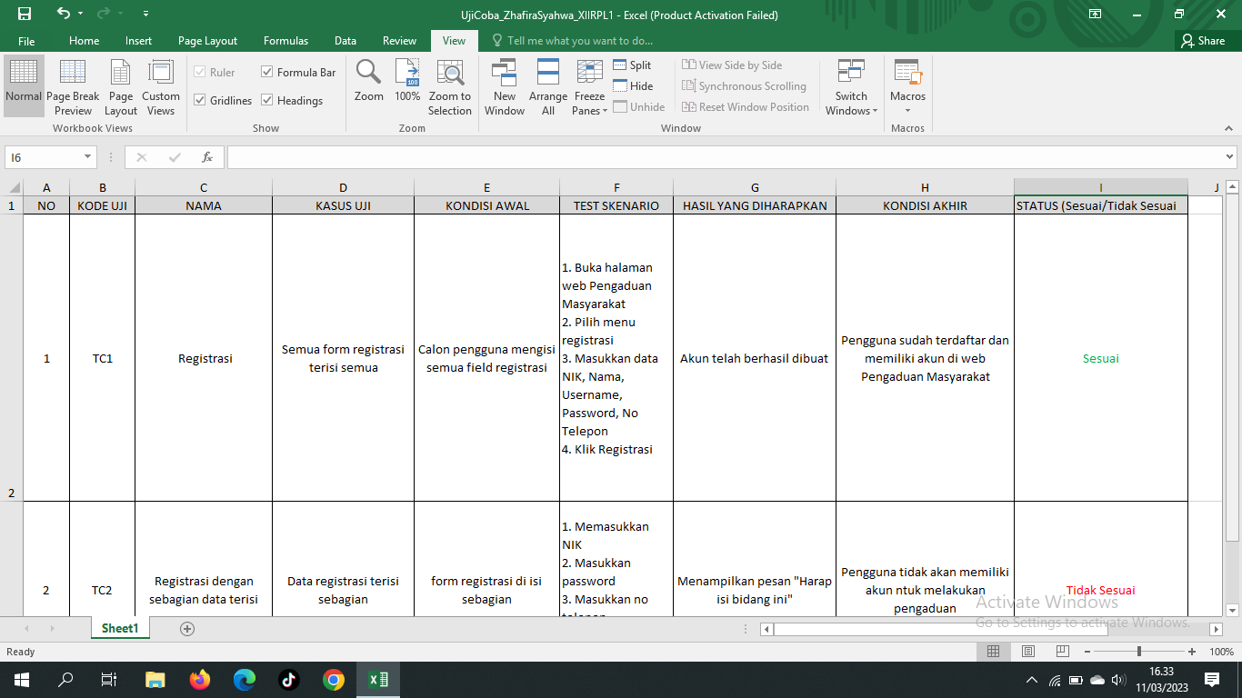

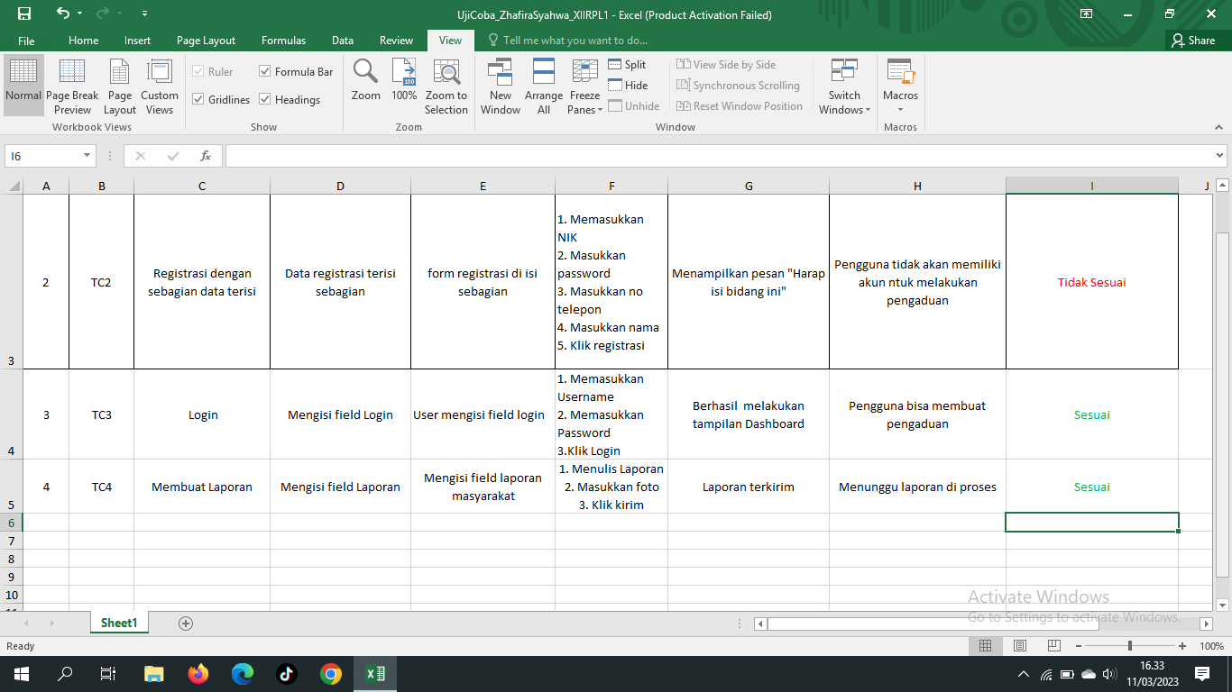

1. REVISI
2. PENENTUAN DOMAIN DAN HOSTING
3. UPLOAD WEB KE HOSTING
4. UPLOAD WEB KE GITHUB
5. PEMBUATAN USER GUIDANCE